|  |
| --- |
| Jitter Client – Architecture and Design Document |
|  |
|  |
| **Lakshmikanth Mathur** |
| **10/15/2013** |

**Version History**

|  |  |  |  |
| --- | --- | --- | --- |
| **Version No** | **Updates** | **Date** | **Author** |
| **0.1** | **Draft version of Architecture block diagram, class diagram and Use case** | **10/13/2013** | **Lakshmikanth Mathur** |
| **0.2** | **Updated to use the name of Jitter Client instead of Twitter Client** | **10/15/2013** | **Lakshmikanth Mathur** |

**Architecture Block Diagram**

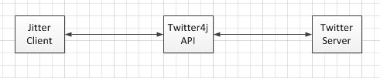

**Class Diagram**

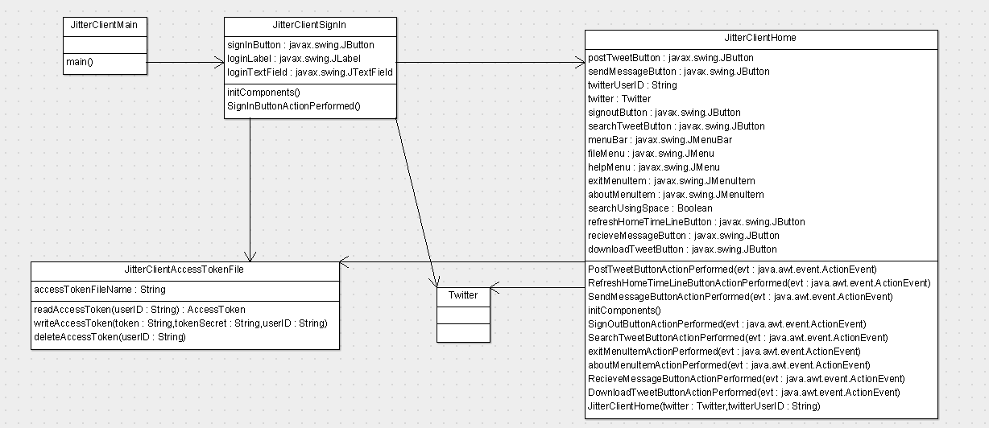

**Use Cases**

